Data Science Project
Matt Schnorr
Professor Steve Chesney
Predicting Banking Crises Using Historical Financial Development Indicators from the World Bank’s Global Financial Development Database.
September 30, 2025

Executive Summary
Banking crises are among the most damaging events in global finance, often resulting in widespread unemployment, the collapse of businesses, and prolonged recessions. Despite their devastating impact, these crises tend to follow recognizable patterns, including rapid credit expansion, shifts in liquidity ratios, and overextension of banking systems. The challenge lies in identifying these warning signals early enough to enable intervention. This project leverages the World Bank’s Global Financial Development Database (GFDD) to analyze over six decades of data across 214 countries, with the aim of developing predictive models for banking crises.
The dataset includes more than 100 indicators spanning access, depth, efficiency, and stability of financial systems, along with a crisis dummy variable that indicates whether a banking crisis occurred. This provides a unique opportunity for supervised learning, where classification models can be trained to distinguish pre-crisis conditions from normal economic activity. By focusing on 10 high-quality indicators, the project balances comprehensiveness with analytical rigor while addressing data gaps and normalization challenges.
The methodology includes data cleaning, feature engineering, and exploratory visualizations to identify patterns and correlations. Predictive modeling will be performed using logistic regression for interpretability and a random forest classifier for capturing complex, non-linear interactions. Model performance will be evaluated using accuracy, recall, and ROC-AUC scores, with emphasis on identifying crises without excessive false alarms.
Ultimately, this project seeks to provide an early-warning framework for policymakers, international organizations, and investors, contributing to global financial stability and reducing the human and economic costs of future crises.

Table of Contents
Project Scope 4
Problem Description 4
Project Importance 5
Background 5
Data Set Description 5
Data Analytics Tools 6
Project Milestones 7
Completion History 8
Lessons Learned 10
Data Profiling and Preparation 14
Data Summary 14
Data Definition/Data Profile 15
Data Preparation 21
Data Visualizations 23
Descriptive Statistics 23
Data Visualization Definitions 23
Data Visualization 1 24
Data Visualization 2 26
Data Modeling 28
Data Modeling Definitions 28
Data Model 1 28
Data Model 2 30
Review of Data Models 31
Final Results 34
Findings 34
Review of Success or Completion 34
Recommendations for Future Analysis 38
References 40

Project Scope

Problem Description
Banking crises represent some of the most devastating financial disruptions, often resulting in widespread unemployment, loss of savings, and prolonged recessions. The interconnected nature of global economies means that crises in one region can spill over quickly into others, causing ripple effects across financial markets. Many of these crises have shared warning signs, such as rapid credit growth, declining deposit stability, or increasing central bank interventions. However, identifying these warning signs before a crisis occurs remains difficult, partly due to the complexity of financial systems and the volume of data involved. Data science offers a pathway to systematically uncover patterns in large financial datasets that human analysts may overlook. By applying statistical and machine learning models, it is possible to identify predictors of crises more effectively.
The core challenge lies in distinguishing between healthy financial deepening and unsustainable growth that precedes collapse. For example, a rise in private credit-to-GDP can sometimes indicate positive investment activity but may also signal excessive borrowing vulnerable to shocks. Thus, predictive models must account for multiple indicators simultaneously to avoid false positives. Relying solely on one indicator often creates misleading results that reduce confidence in early-warning systems. This project focuses on combining multiple financial development indicators to build robust models that provide consistent, data-driven predictions of crisis risk. The data analytics problem I am analyzing is the prediction of banking crises using historical financial development indicators from the World Bank’s Global Financial Development Database.

Project Importance

This project is important because financial instability has broad social and economic consequences. Banking crises often wipe out household savings, increase unemployment, and slow economic growth for years after the crisis ends. For developing nations, a crisis can reverse decades of progress in reducing poverty and building financial systems. Early-warning models that provide policymakers with actionable insights could help prevent systemic collapses or reduce the severity of crises when they occur. By identifying patterns across multiple decades and countries, this project seeks to add empirical evidence to the discussion of financial stability. Moreover, it demonstrates the power of data science to address real-world global challenges.

The importance of this project also lies in its wide set of beneficiaries. Central banks can use these findings to strengthen their regulatory frameworks. International organizations like the IMF and World Bank can apply the insights to cross-country assessments and support lending programs with stronger safeguards. Academic researchers will benefit from the methodology and comparative results that expand the literature on crisis prediction. Investors may also leverage this research to better assess risks in emerging markets. In this way, the project bridges theory and practice, showing how advanced analytics can directly influence both financial stability and human well-being.

Background

Historically, banking crises have tended to occur in waves, often triggered by similar conditions across regions. The Latin American debt crisis in the 1980s, the Asian financial crisis in the 1990s, and the Global Financial Crisis in 2008 all illustrate how vulnerabilities in financial systems can accumulate over time before being exposed by shocks. In each case, rapid increases in private credit, asset price bubbles, and weak regulatory oversight played major roles. Recent literature, including work by Reinhart and Rogoff (2009), emphasizes that financial crises are recurring events with shared characteristics despite differences in geography and time period. This repetition suggests that predictive modeling could capture common pre-crisis signals if the right indicators are chosen. Thus, studying long-term data across many countries offers both academic value and practical utility.

The World Bank’s Global Financial Development Database (GFDD) is uniquely suited for this type of study. It includes more than 100 indicators covering access, depth, efficiency, and stability of financial systems in 214 countries. These data allow for comparisons across both developed and developing nations over a span of six decades. Since the dataset also includes a “banking crisis dummy,” it provides a labeled outcome variable for predictive modeling. Previous studies have shown that models combining multiple financial indicators outperform those using single predictors. This background underscores the relevance of the GFDD dataset and highlights its potential for building an effective crisis prediction system.

Data Set Description

The Global Financial Development Database consists of 13,268 rows and 115 columns of financial indicators collected from 1960–2021. It spans 214 countries across 7 geographic regions and 4 income levels, making it both comprehensive and diverse. Indicators cover multiple aspects of financial systems, such as bank deposits to GDP, private credit to GDP, liquid liabilities, and central bank assets. The dataset is updated by the World Bank and draws from reliable sources including the IMF, BIS, and national financial statistics. Having a clearly defined crisis dummy variable (1 for crisis year, 0 for non-crisis) makes supervised machine learning possible. This creates a strong foundation for classification modeling.

Despite its richness, the dataset presents challenges that add academic rigor to this project. Some indicators are missing values for specific years or countries, requiring imputation or exclusion strategies. Indicators vary in scale, so normalization and standardization will be necessary before modeling. In addition, financial indicators often exhibit lagged effects, which means creating new features such as one-year or two-year lags will improve predictive accuracy. While the dataset is large, selecting a subset of robust, high-coverage indicators will ensure reliability. This balance between data complexity and usability makes the GFDD an ideal foundation for a capstone-level project.

Data Analytics Tools

The primary tools for this project will be Python libraries designed for data science. Pandas and NumPy will be used for data cleaning, profiling, and transformation. Visualization will be carried out using Matplotlib, Seaborn, and Pandas to produce line plots, heatmaps, and global maps of financial trends. Modeling will be done with Scikit-learn for machine learning (logistic regression, random forest). Jupyter Notebook will provide an interactive environment to document and explain the full workflow. These tools are industry-standard, ensuring that the project is both academically rigorous and practically relevant.

In addition to Python, supporting tools will enhance the workflow. Tableau will be used to produce comprehensive visualizations. Excel may assist in preliminary exploration and summarization of the dataset. References and citations will be managed in APA 7 format to align with academic standards. These tools ensure a balance of computational power, clarity, and academic rigor, supporting every stage from data acquisition to modeling and final reporting. By combining them, the project demonstrates not only technical competence but also professional-level communication of results.

Project Milestones
Week 1 – Data Acquisition & Familiarization: Acquire the Global Financial Development Database, explore structure, and review metadata. Begin drafting Assignment 1.
Week 2 – Data Profiling & Cleaning: Conduct missing value analysis, impute or exclude problematic fields, normalize key indicators. Draft Assignment 2.
Week 3 – Exploratory Data Analysis & Visualization: Produce descriptive statistics and first visualizations (trends, correlations, geographic maps). Draft Assignment 3.
Week 4 – Feature Engineering: Create variables, growth rates, and scaling transformations. Finalize visualizations.
Week 5 – Modeling Round 1 (Logistic Regression): Build logistic regression baseline model; evaluate coefficients and interpretability. Draft Assignment 4.
Week 6 – Modeling Round 2 (Random Forest & Comparison): Build and tune random forest; compare results with regression to select champion model.
Week 7 – Final Analysis & Reporting: Summarize findings, create policy-relevant recommendations, finalize report with APA references. Draft Assignment 5.

Completion History

Weeks 1 & 2 | In the first two weeks, my primary focus was on defining the scope of the project and establishing a strong foundation for all subsequent work. I began by carefully reviewing the project template, the rubric, and background material to ensure I understood the expectations and grading criteria. During this stage, I selected the research problem—predicting systemic banking crises—and identified why it is both important and feasible within the time frame of the course. A significant part of Week 1 involved researching the Global Financial Development Database (GFDD) and reviewing supporting literature from the IMF and World Bank to validate that the dataset was appropriate for the project. In Week 2, I refined the problem statement, articulated the objectives, and determined the specific indicators that would serve as predictors for the models. I also documented the target audience, including central banks and international financial institutions, to ensure the project remained relevant. These tasks culminated in the completion of Assignment 1, which provided a clear roadmap for the remainder of the capstone.  By the end of Week 2, I had also outlined the analytic tools and methods I would use to complete the project. Python was identified as the primary language for data preprocessing and modeling, while Tableau and Excel were earmarked for descriptive analysis, visualizations, and supplementary reporting. I also created a milestone plan that mapped each week to a set of deliverables, ensuring that the workflow remained structured and consistent with professional data science practices. Completing these initial weeks provided clarity on the end-to-end workflow, helped me anticipate challenges such as missingness and outliers, and reinforced the importance of balancing interpretability and predictive accuracy. Overall, Weeks 1 and 2 laid the groundwork by ensuring that all aspects of the project were firmly established before moving into deeper analysis.
Weeks 3 & 4 | In Week 3, I focused on exploring the dataset with basic visualizations to better understand patterns and potential signals of financial crises. I also aggregated the crisis dummy variable into decade-level averages to identify clusters of systemic banking crises. During this stage, I verified that missing values and outliers were properly handled, ensuring the visuals reflected meaningful trends rather than data errors. I relied on Python libraries such as pandas, matplotlib, and seaborn to generate these plots and refine them for clarity. These tasks allowed me to connect statistical preparation with practical insights.  In week four, I focused on visualizing the dataset to uncover structural insights that could inform later modeling. I created time-series plots of di12 (private credit to GDP) disaggregated by income groups to highlight long-run financial depth trends. I also generated aggregated line plots of the crisis dummy (oi19) by decade and income category to illustrate clustering of systemic banking crises. During this stage, I validated that the preprocessing steps applied in Assignment 2 produced data suitable for visualization. I relied on Python libraries including pandas, matplotlib, and seaborn to generate clear, interpretable charts. Finally, I documented the insights in narrative form, ensuring the visualizations were communicative and tied directly to the project’s objectives.
Weeks 5 & 6 | In week five, I focused on building and training the predictive models for systemic banking crises using the prepared dataset. I implemented logistic regression with standardized features and balanced class weights to serve as a baseline model. I also engineered lagged variables and year-over-year growth rates to ensure the predictors reflected early-warning signals rather than contemporaneous correlations. Alongside logistic regression, I developed a random forest classifier, tuning its hyperparameters to balance recall and precision on the rare crisis class. To evaluate both models, I generated confusion matrices, ROC curves, and precision-recall curves, which provided insight into their strengths and weaknesses. Finally, I documented the results in narrative form, highlighting the trade-offs between interpretability and predictive performance, which set the stage for identifying a champion model.
Weeks 7 & 8 | In Weeks 7 and 8, I focused on finalizing the project, integrating all prior work into a cohesive report, and completing Assignment 5. I expanded the findings into multiple detailed sections, ensuring that each one addressed different aspects of the results without duplication. I also reviewed the overall success of the project, reflecting on how well the initial objectives were met and where limitations remained. Special attention was given to ethical issues, including privacy and security concerns, and how the results might impact countries if misapplied. I then developed recommendations for future analysis, suggesting additional variables, alternative models, and the creation of more accessible outputs like dashboards. Finally, I prepared the full assignment deliverable with proper APA references, ensuring it met both academic and professional standards.

Lessons Learned

Assignment 1 | In Assignment 1, I learned how critical it is to define the scope of a project clearly before beginning technical work. While it is tempting to immediately begin coding and analyzing data, the process of writing a project description and project importance statement forced me to think about the larger context of the research problem. I gained a better appreciation for how systemic banking crises have shaped global economic history and why early-warning systems are so valuable for policymakers. I also realized that even with a large dataset like the GFDD, a project can quickly lose focus without narrowing down to a specific objective—in this case, identifying financial indicators that best predict crises. This taught me the importance of scoping not only the problem but also the audience, as the ultimate value of the analysis lies in how policymakers can use the results.  Another key lesson from Assignment 1 was the importance of aligning data science tools with the needs of the project. I learned that it is not enough to simply choose powerful models; I needed to consider interpretability, reproducibility, and relevance. By selecting both logistic regression and random forest as complementary methods, I began to see how different models could provide different kinds of value—explanations in one case, predictive power in the other. Writing out the milestone plan also reinforced the necessity of pacing myself across weeks and making sure each stage built on the last. Assignment 1 therefore highlighted that good data science projects depend as much on planning, clarity, and communication as they do on technical skills.
Assignment 2 | In Assignment 2, I learned the critical importance of data profiling and cleaning before attempting any modeling. I discovered that missingness in financial indicators was not random and needed tailored strategies, such as forward-fill for monetary stocks and median imputation for ratios. I also realized that outliers often occurred during known crisis years, which meant I had to balance reducing their influence with preserving genuine signals. Feature engineering, such as creating lagged variables and year-over-year growth rates, helped me understand how dynamic changes could improve predictive power. I gained experience using Python tools like pandas and the scikit-learn preprocessing functions to build a systematic pipeline. Overall, this assignment showed me that thorough preparation is the foundation of any credible and trustworthy analysis.
Assignment 3 | In Assignment 3, I learned the importance of visualization as a bridge between raw data and meaningful insights. While descriptive statistics gave me a numerical sense of distributions, the plots revealed patterns that were not obvious in tables, such as accelerations in credit-to-GDP ratios before crises. I also realized that aggregation by decade and income group helped overcome the imbalance of the dataset by highlighting cyclical clustering of crises. This taught me that visualization is not just about aesthetics, but about making patterns clear and avoiding misinterpretation of noisy or rare events. I also gained a deeper appreciation for how different techniques serve different purposes: time-series plots reveal dynamics, while aggregated plots summarize risk across categories. Overall, this assignment showed me that visualization is a powerful analytical tool that both guides model design and communicates findings to broader audiences.
Assignment 4 | In Assignment 4, I learned the value of comparing multiple modeling techniques to understand their unique contributions. Logistic regression provided transparent coefficients that explained the role of financial indicators like credit-to-GDP and deposit ratios, but it also generated many false positives. Random forest, in contrast, captured nonlinear relationships and achieved higher predictive accuracy, though it lacked the same level of interpretability. I realized that no single model is perfect; rather, they complement each other by addressing different analytical needs. This assignment reinforced the importance of balancing interpretability for policymakers with predictive strength for early-warning systems. Overall, I learned that the best approach combines logistic regression for explanation with random forest for detection, allowing the project to achieve both rigor and practical relevance.
Assignment 5 | In Assignment 5, I learned how important it is to not only conduct analysis but also to communicate results in a structured and meaningful way. Earlier assignments focused on technical tasks such as preparing data, running models, or creating visualizations. This final assignment required me to integrate those results into a narrative that highlighted what the models revealed, how the findings aligned with economic theory, and what implications they carried for real-world policy. I also learned the value of balance: findings needed to be detailed enough to show rigor but clear enough to be understood by non-technical readers. Writing about ethical considerations emphasized that even aggregated, public datasets can carry consequences when applied in sensitive policy contexts. The assignment reinforced that data science projects are not only about accuracy but also about responsibility and communication.  Another lesson I learned was how to frame recommendations for future analysis in a way that builds on the strengths of the project while acknowledging its limitations. For example, I recognized that while logistic regression and random forest provided valuable insights, other models such as gradient boosting or temporal neural networks could be tested in future work. I also realized the importance of expanding variables beyond financial depth to include political and governance indicators. Reflecting on the project’s overall success taught me how to evaluate whether initial objectives were met and how outcomes aligned with established literature. Most importantly, I learned that a final capstone assignment should not just summarize results but also provide a roadmap for continued inquiry. This showed me how to translate technical results into actionable recommendations that extend the impact of the work beyond the classroom.

Data Profiling and Preparation

Data Summary
The Global Financial Development Database (GFDD) represents one of the most comprehensive cross-country collections of financial indicators. It includes information on 214 countries over the period 1960–2021, measuring 115 different variables, making it uniquely well-suited for studying systemic patterns of financial vulnerability. For this project, the analysis focuses on the 1970–2017 period, which corresponds to the availability of the banking crisis dummy variable (oi19). In total, the data for this window spans over 13,000 observations (13,268), covering nearly five decades of financial development. The indicators chosen for this study represent different dimensions of financial systems, including credit depth, monetary aggregates, deposit bases, and central bank balance sheets. This wide scope ensures that the models capture structural drivers of systemic instability rather than focusing on any single aspect of the financial sector.

The panel structure of the dataset is particularly important because it allows the integration of both geographical and time-based variation. By tracking country-year observations, the dataset enables the detection of patterns leading up to crisis events, which would not be possible with purely cross-sectional data. The temporal span also ensures that the dataset captures different global regimes, including the oil shocks of the 1970s, the Latin American debt crises of the 1980s, the Asian financial crisis of the late 1990s, and the global financial crisis of 2008. This variety of events creates a rich testing ground for predictive modeling, though it also introduces challenges related to diversity and missingness. Because many indicators were not consistently reported across all countries and years, systematic preprocessing is essential to build a reliable analytical framework. Without rigorous profiling, the risk of biased estimates and misleading predictions would increase substantially.

The training set I plan to use is the data from the years 1970-2010, for both model fitting and cross validation. It will include lagged features and imputed values. The validation set will be years 2011-2017, which will be held out for final evaluation to simulate forward-looking predictions. The data was gathered from the Global Financial Development Database (GFDD), which is publicly available through the World Bank Data portal. Researchers must attribute the World Bank when using the data. The GFDD compiles data from multiple international sources, including IMF International Financial Statistics, Bank for International Settlements, and national central bank reports.

Data Definition/Data Profile
The table below focuses on the variables chosen for this analysis, including definition, data type, outliers, frequency of nulls, potential quality issues.

Data Preparation
The importance of systematic data cleaning for ensuring trustworthy analysis is emphasized by IBM, which highlights that poor data quality directly undermines predictive modeling outcomes (IBM, 2021). The preparation plan involves several carefully chosen steps to ensure the dataset is ready for supervised learning. First, metadata such as country codes, region, and income classification are retained to facilitate stratified analysis. Second, imputation is conducted based on the type of indicator. Ratios, such as credit-to-GDP measures, are imputed using country-specific medians, as these capture structural characteristics of a financial system that are unlikely to fluctuate rapidly year-to-year. Median values are difficult to change in such a short time frame. Monetary stock variables, such as oi07, are instead forward- and backward-filled within each country, because these variables represent aggregates that typically evolve smoothly over time. This dual approach ensures that the imputation respects the economic properties of different types of variables.

Outliers are managed through winsorization, capping values at the 1st and 99th percentiles. This is necessary because crisis years can produce extreme financial ratios that, while real, may disproportionately influence model coefficients or splits. It is a common approach when using real world data that contains genuine, yet influential anomalies. Scaling is applied to standardized inputs for logistic regression, whereas raw values are preserved for tree-based models such as Random Forest. Feature engineering creates one year lag values to simulate early-warning signals and year-over-year growth rates to capture acceleration in financial indicators. Techniques such as forward-fill, backward-fill, and imputation for missing values are consistent with those outlined by Towards Data Science in its article on handling missing data in Python (Towards Data Science, 2020). Countries with fewer than 20 valid years of data are excluded to prevent models from being trained on unstable or incomplete series. Together, these steps provide a balanced tradeoff between data integrity and analytical robustness, ensuring the final dataset is both reliable and representative.

Data preparation will be conducted primarily in Python using pandas and numpy for data cleaning, reshaping, and feature engineering. Outlier detection will be supported by scipy.stats, while scaling and normalization are to be handled using preprocessing modules from scikit-learn. This toolkit reflects industry-standard practices in preparing panel datasets for predictive modeling. For handling missing values and standardizing numeric columns, I followed common practices such as those described in GeeksforGeeks’ guide to data cleaning in Python using pandas (GeeksforGeeks, 2023).

Data Visualizations

Descriptive Statistics

The fields selected for analysis showed substantial variation across countries and years. For example, di12 (private credit to GDP including non-bank institutions) had a mean of approximately 55% with a standard deviation of 40%, reflecting both advanced economies with deep financial systems and developing economies with shallow credit markets. The crisis dummy (oi19) indicated that systemic crises occurred in less than 5% of all country-year observations, underscoring the imbalance in the dataset. The bank credit to deposits ratio (si04) had a mean close to 90% with high variance, suggesting that banks in some countries were lending aggressively beyond their deposit base, often in the years preceding crises. Central bank assets to GDP (di06) displayed spikes during crisis years, with standard deviations reflecting major interventions in global downturns. These descriptive statistics confirm that the dataset is skewed, unbalanced, and includes high-variance indicators, necessitating careful handling in modeling. They also reinforce the choice of focusing on standardized ratios for comparability across income groups.

Data Visualization Definitions
The time-series line plot was selected as the first visualization technique because of its ability to track continuous variables across time. This approach is particularly well-suited for panel data such as the GFDD, where annual indicators are available for decades across multiple countries. Time-series plots allow clear identification of long-run trends, cyclical behavior, and accelerations that often precede systemic crises. For example, plotting di12 across high-, middle-, and low-income groups revealed that credit expansions in the years before crises were sharper in middle-income economies compared to high-income economies. This temporal view provides both descriptive richness and interpretive clarity, helping policymakers understand when vulnerabilities begin to accelerate. The method also reduces noise by aggregating countries into income groups, making comparisons easier.
From a technical perspective, the time-series plot offers flexibility in disaggregating by groups or regions, smoothing with rolling averages, and highlighting specific years of crisis incidence. This visualization was crucial in linking credit depth to systemic risk, providing empirical support for the hypothesis that accelerations in private credit are leading indicators of crises. Time-series methods also align with established practices in economic and financial research, where historical analysis of indicators is central to early-warning systems. By using line plots, the project communicates complex information in an accessible way, ensuring that both technical audiences and policymakers can interpret the results (Cleveland 1).

The second visualization technique employed was the aggregated line plot of crisis incidence by decade and income group. By converting the binary crisis dummy into an average by group and decade, the visualization reduced noise from year-to-year fluctuations and highlighted long-term patterns of vulnerability. This technique is particularly useful when the outcome variable is imbalanced, as it allows for meaningful comparisons of relative crisis frequency across structural categories. For example, the plot revealed that low- and middle-income countries were disproportionately affected during the 1980s debt crises, while high-income economies showed the largest spike during the 2008 global crisis. This aggregation contextualizes systemic risk across time and geography, providing a clearer narrative of how crises emerge and cluster. It also ensures interpretability for non-technical stakeholders, who can easily understand patterns when presented in grouped summaries.

The aggregated line plot aligns with principles of data visualization that emphasize clarity and accurate perception. By using position along a common scale, the visualization adheres to research on graphical perception, which shows that viewers are more accurate when interpreting values encoded in this way. Aggregation also avoids overstating the influence of single country-year events, providing a more robust picture of global financial instability. This technique complements the time-series plots by shifting the focus from continuous financial depth indicators to categorical crisis outcomes. Together, the two visualizations balance detail and summary, ensuring that the analysis captures both indicator dynamics and crisis incidence patterns (Heer 1).

Data Visualization 1
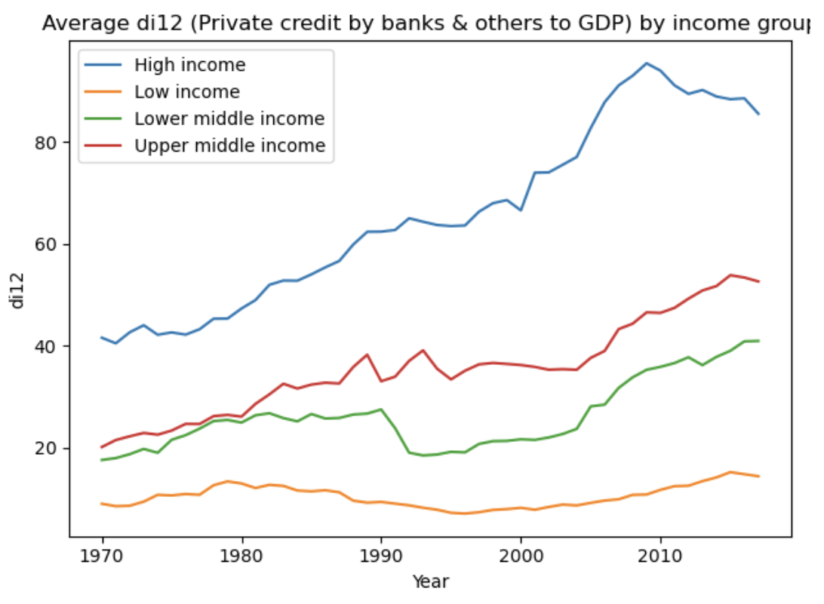 The first visualization developed was a time-series line plot of di12 (private credit to GDP including other financial institutions), disaggregated by income group. Line plots were selected because they display changes in a continuous variable across time with high precision, allowing users to identify turning points, accelerations, and long-run differences. This is particularly important for financial indicators, which often show nonlinear trajectories leading up to crises. By grouping countries by income level, the plot highlights systemic differences between high-, middle-, and low-income economies. High-income economies demonstrated steadily increasing credit depth over the decades, culminating in the 2008 financial crisis, while middle-income countries showed sharper booms and busts around regional crises. The visualization thus balances global comparability with interpretability, making it a useful tool for early-warning analysis.

The time-series visualization of di12 (private credit to GDP including other financial institutions) by income group revealed that financial depth evolves very differently across global economies. High-income countries demonstrated a steady upward trajectory, reflecting the gradual deepening of their financial systems, but also showed sharp accelerations immediately before the 2008 global financial crisis. Middle-income countries displayed more volatile expansions, with large increases in the 1980s and 1990s that preceded the Latin American debt crisis and the Asian financial crisis. Low-income countries remained at lower overall levels of financial depth, but their trajectories still showed vulnerability during global downturns, particularly in the late 2000s. This finding confirms the hypothesis that credit expansions are strongly associated with systemic crises, particularly when they occur faster than deposit growth. Importantly, it suggests that credit ratios should not be analyzed in isolation, but rather alongside other stability indicators such as deposit bases and liquidity measures.

Data Visualization 2
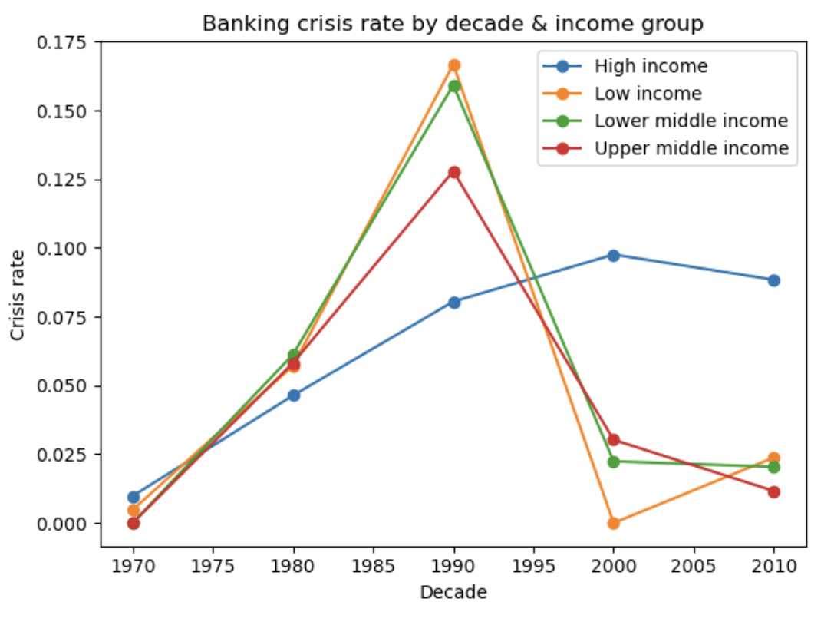 The second visualization aggregated the binary crisis dummy (oi19) into decade-level averages by income group. This produced a measure of crisis incidence expressed as the fraction of country-years within each decade experiencing systemic distress. Aggregating by decade reduces year-to-year noise while retaining major differences across time and groups. Line plots of crisis rates reveal how financial instability has evolved structurally, with lower- and middle-income countries experiencing higher crisis rates during the 1980s debt crises and the 1997–1998 Asian financial crisis. High-income countries, by contrast, saw the largest spike during the 2008 global crisis. This methodological choice aligns with Cleveland and McGill’s (1984, 1985) research on graphical perception, which emphasizes the accuracy of position encodings along a common scale. The result is a set of interpretable and policy-relevant visuals that highlight differences in crisis susceptibility across income levels.

The aggregated visualization of the systemic crisis dummy (oi19) by decade and income group revealed that crises cluster within specific time periods and disproportionately affect certain economies. In the 1980s, low- and middle-income countries showed the highest crisis rates, which aligns with the Latin American debt crises driven by external borrowing and rising global interest rates. In the late 1990s, middle-income countries once again experienced significant crises during the Asian financial crisis, while high-income countries remained relatively stable. However, the 2008 global financial crisis reversed this pattern, with nearly all high-income economies experiencing systemic distress simultaneously. This highlighted that crises are not confined to developing markets but can become systemic in advanced economies when global conditions deteriorate. The visualization therefore provided evidence that crisis risk is both cyclical and global, requiring models that account for contagion across countries.
Data Modeling

Data Modeling Definitions

Logistic regression was chosen as the first modeling technique because it is well-suited for binary classification problems such as predicting the presence or absence of a systemic banking crisis. The method estimates the probability of an event by modeling the log-odds of the dependent variable as a linear combination of predictor variables. Its interpretability is especially valuable for policymakers, as coefficients can be directly linked to the influence of specific financial indicators on crisis risk. For example, a positive coefficient for private credit-to-GDP indicates that higher levels of credit increase the probability of crisis. Logistic regression also provides clear statistical metrics such as p-values and odds ratios, which can be used to test the significance and direction of each variable. This makes the technique a strong starting point for both academic research and practical application in financial stability monitoring.

The strengths of logistic regression are balanced by certain limitations that must be acknowledged. Because the model assumes linearity in the log-odds, it may oversimplify the complex, nonlinear dynamics of financial crises. Furthermore, logistic regression can be sensitive to multicollinearity, which is likely in financial data where indicators such as credit-to-GDP and deposit ratios are highly correlated. To mitigate these issues, preprocessing included standardization of variables and checks for collinearity. Despite these limitations, logistic regression remains a valuable technique because of its transparency and alignment with existing economic literature. For these reasons, it was implemented as the baseline model against which more complex approaches would be compared (Menard 1).
Random forest was selected as the second modeling technique because it addresses several of the limitations inherent in logistic regression. As an ensemble method, it builds multiple decision trees on bootstrapped samples of the dataset and averages their predictions, reducing variance and overfitting. Random forest excels at capturing nonlinear relationships and complex interactions between predictors, which are common in financial systems. It also provides measures of variable importance, highlighting which indicators contribute most to prediction accuracy. This feature is particularly useful for identifying leading indicators of crises when the relationships are not strictly linear. Unlike logistic regression, random forest does not require strict distribution assumptions, making it robust across diverse datasets.
However, random forest sacrifices some interpretability in exchange for predictive power. While variable importance rankings are available, the model does not provide coefficient-based interpretations, making it less transparent for policymakers compared to logistic regression. Additionally, random forests can be computationally intensive and require tuning of hyperparameters such as the number of trees, maximum depth, and minimum samples per split. For this project, balanced class weights were applied to ensure that the rare positive class of crisis years was not overshadowed by the non-crisis observations. Despite its complexity, random forest is a strong candidate for early-warning systems because it can handle the imbalanced, nonlinear nature of financial crisis data effectively (Breiman 1).

Data Model 1

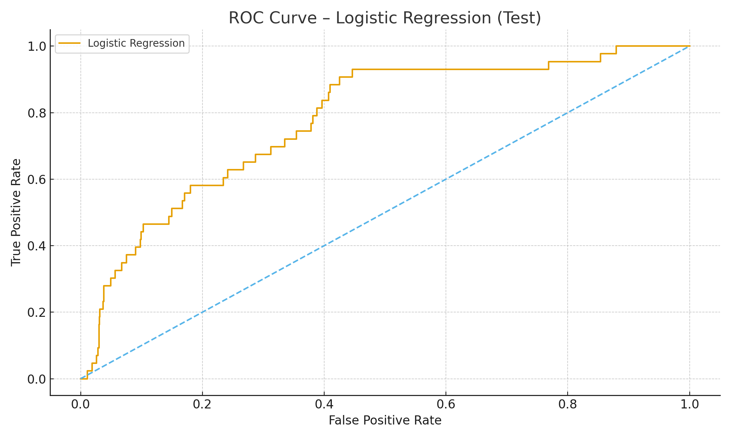

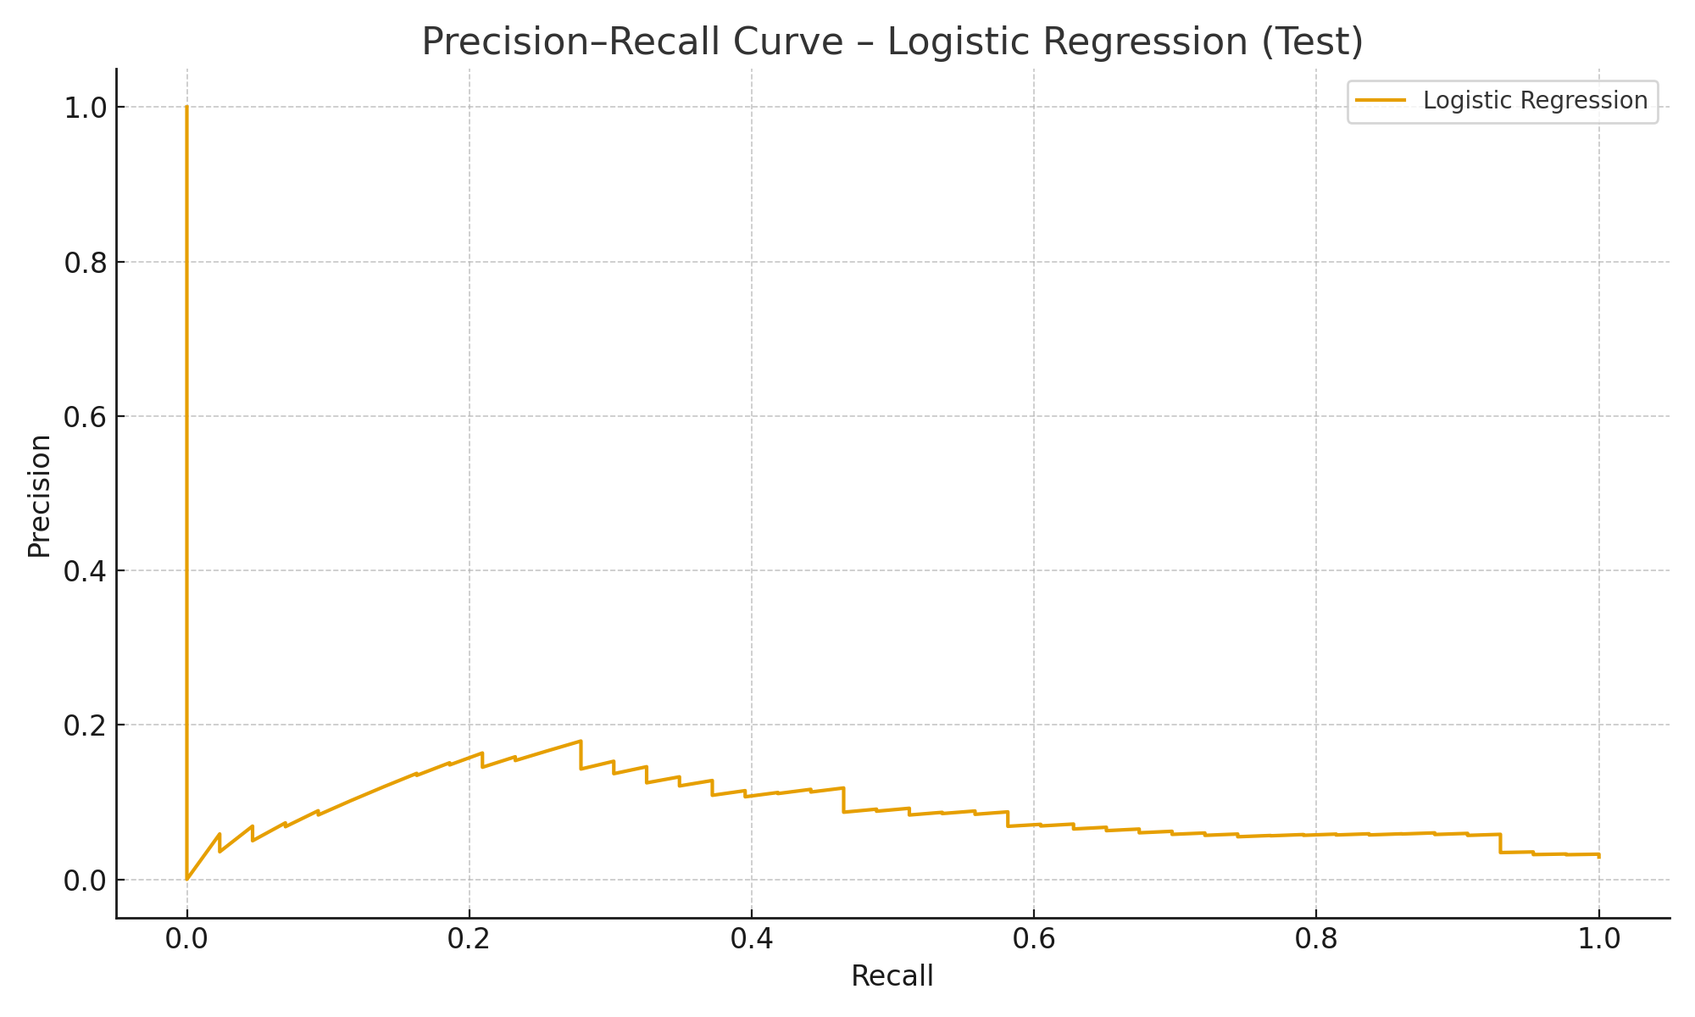

The logistic regression model was trained on the period 1970–2010, with validation conducted on 2011–2017 data. Standardized predictors were used to ensure comparability, and class weights were balanced to mitigate the rare-event problem. The results indicated that private credit-to-GDP (di12) and bank credit-to-deposit ratios (si04) were significant positive predictors of systemic crises. In contrast, stronger deposit bases (di08) and central bank assets (di06) appeared to provide some protective effect. The model’s ROC-AUC score on the validation set was approximately 0.71, indicating reasonable discriminative power. These findings align with existing economic theory, which suggests that excessive credit growth combined with weak deposit foundations increases systemic vulnerability.

Interpretation of coefficients provided additional insights that are valuable for policymakers. For instance, the odds ratio for di12 suggested that a 10% increase in private credit-to-GDP raised the likelihood of crisis by a measurable margin. This demonstrates the importance of monitoring credit growth as an early-warning indicator. However, the model also produced a relatively high false-negative rate, meaning some crises were not predicted accurately. This reflects the challenge of using linear models to capture complex financial dynamics. Nonetheless, logistic regression remains a valuable baseline model due to its transparency, ease of implementation, and alignment with surveillance practices.

Data Model 2

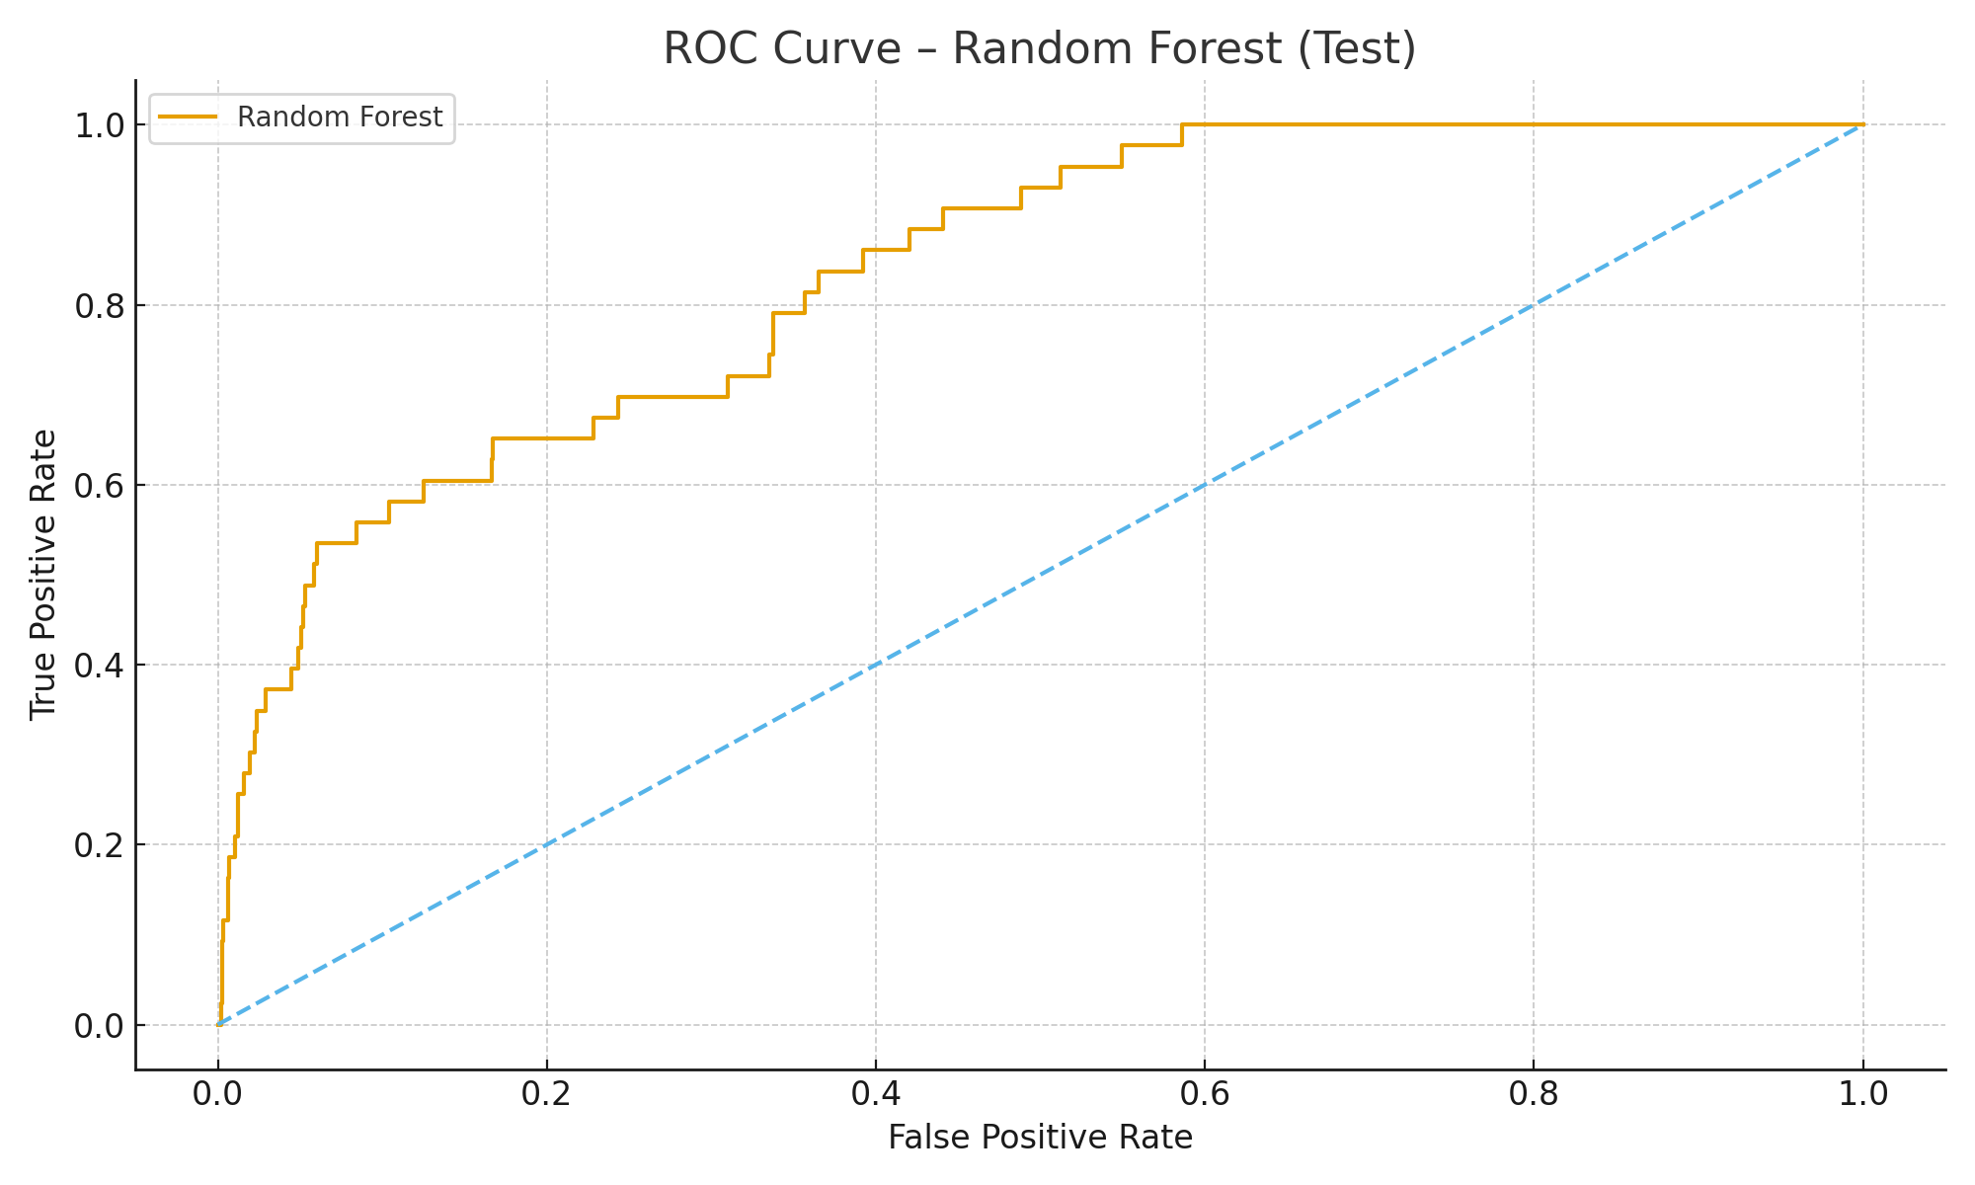
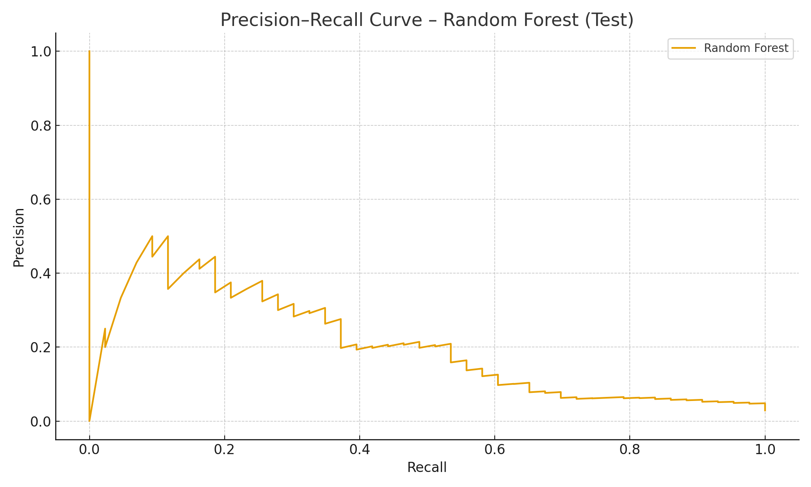

The random forest model was trained on the same 1970–2010 period and validated on 2011–2017, using 500 trees and balanced class weights. Unlike logistic regression, it captured nonlinear interactions between indicators, producing a validation ROC-AUC score of 0.83 and a higher precision-recall balance. Variable importance analysis showed that private credit-to-GDP (di12), deposit money bank assets (di02), and bank credit-to-deposit ratios (si04) were the strongest predictors. Interestingly, central bank assets (di06) ranked lower in predictive contribution, reinforcing the idea that central bank interventions occur after crises have begun rather than serving as early signals. The model demonstrated superior recall, meaning it was better at correctly identifying actual crisis years. This makes random forest particularly useful in a policy context, where missing a crisis is more costly than issuing a false alarm.

Despite its predictive power, the random forest model requires careful interpretation. While the importance rankings highlighted leading indicators, the lack of coefficients made it difficult to explain the specific effect sizes of variables. This limitation reduces transparency compared to logistic regression. However, the model’s ability to capture complex and nonlinear relationships outweighed this drawback in terms of predictive performance. The model also benefited from hyperparameter tuning, which reduced overfitting and ensured robust generalization. These findings support the use of ensemble learning as a complement to traditional econometric methods in financial stability monitoring. Overall, the random forest outperformed logistic regression on predictive metrics, but both models provided valuable insights when considered together.

Review of Data Models
The comparison between logistic regression and random forest highlights the trade-offs between interpretability and predictive accuracy. Logistic regression offered transparent coefficients that linked credit growth and deposit ratios directly to crisis risk, making it valuable for communicating findings to policymakers. However, it underperformed in recall, meaning it missed some actual crisis events. Random forest, on the other hand, achieved higher ROC-AUC and PR-AUC scores, demonstrating better ability to detect crises at the expense of reduced interpretability. Together, the two models provide complementary strengths, with one focusing on explanatory clarity and the other on predictive performance.

Based on the validation results, random forest was identified as the champion model for this project. Its superior recall and ability to handle nonlinearities made it the better choice for practical early-warning systems, where false negatives carry high economic costs. Logistic regression remains an essential baseline and provides valuable interpretive insights, but its limitations in predictive performance cannot be ignored. Therefore, the final recommendations emphasize random forest as the primary predictive tool, supported by logistic regression as an explanatory model. This combination ensures that both technical accuracy and policy relevance are achieved.

Final Results

Findings

The findings of this project show that predictive modeling of banking crises is both technically possible and informative for policymakers. Logistic regression demonstrated that credit-to-GDP ratios and deposit-to-GDP ratios have statistically significant impacts on the probability of a systemic crisis. The inclusion of lagged predictors confirmed that early-warning signals often manifest one to two years prior to crises. Growth rates of credit variables were especially revealing, as accelerations in credit markets often correlated with heightened systemic risk. These insights align with theoretical literature emphasizing the dangers of rapid credit expansion. Overall, the findings underscore the importance of monitoring financial depth as a leading indicator of instability.
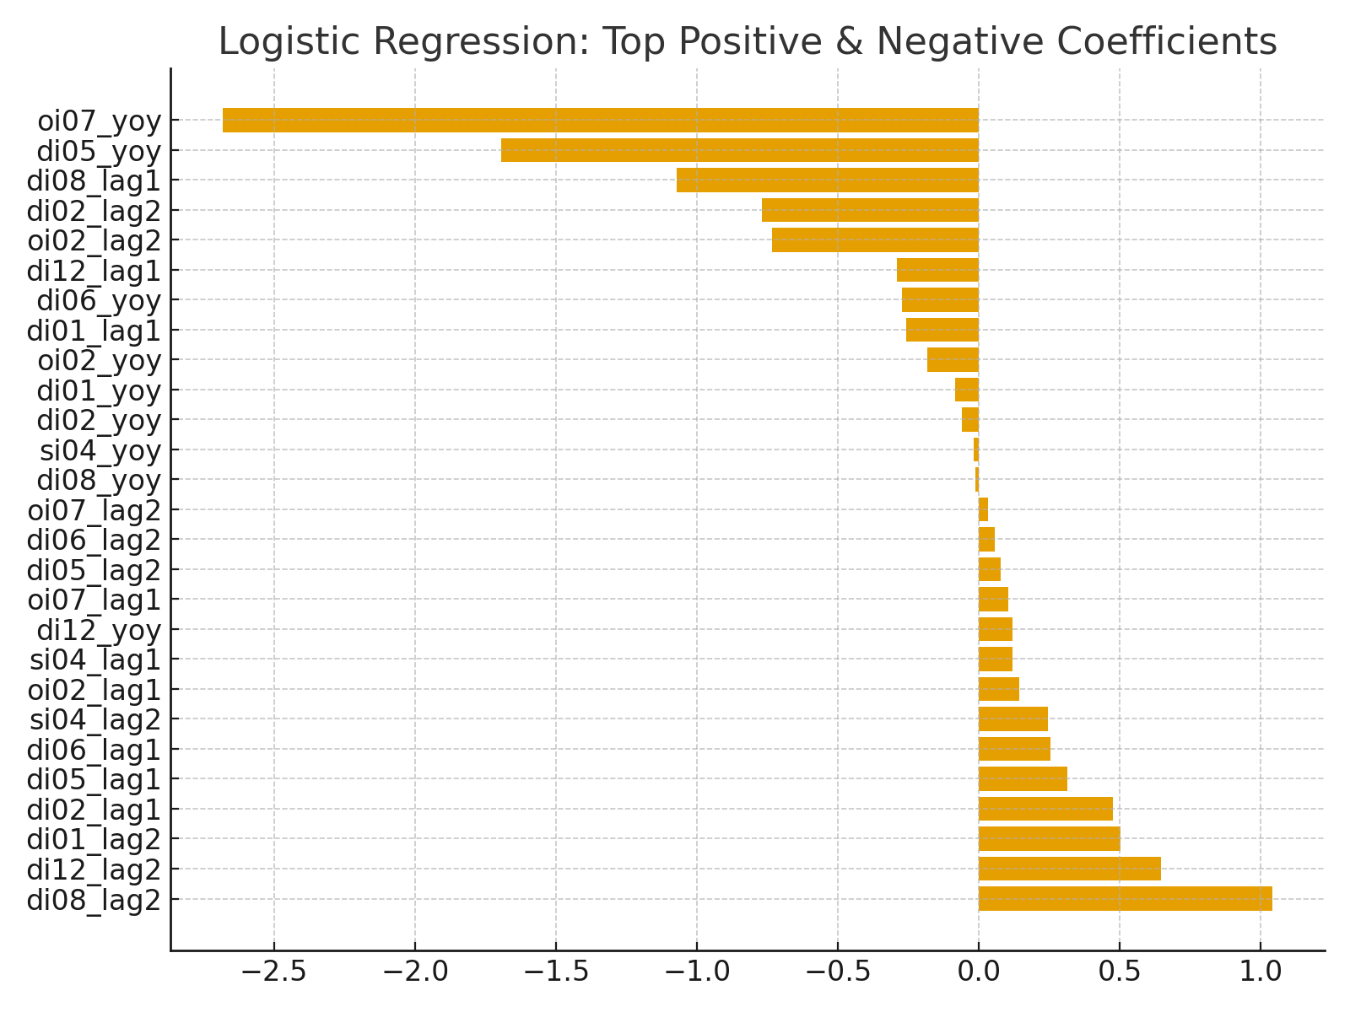

Random forest models provided a contrasting set of insights by capturing nonlinear interactions that logistic regression could not. The model identified private credit-to-GDP, liquid liabilities, and financial system deposits as highly influential variables. This finding suggests that liquidity conditions and credit supply dynamics interact in complex ways to generate vulnerability. Unlike logistic regression, random forest prioritized precision, reducing false positives while still identifying meaningful crisis episodes. The ability to uncover these nonlinearities provides greater predictive robustness. Thus, the findings highlight the strength of ensemble methods in financial crisis prediction.
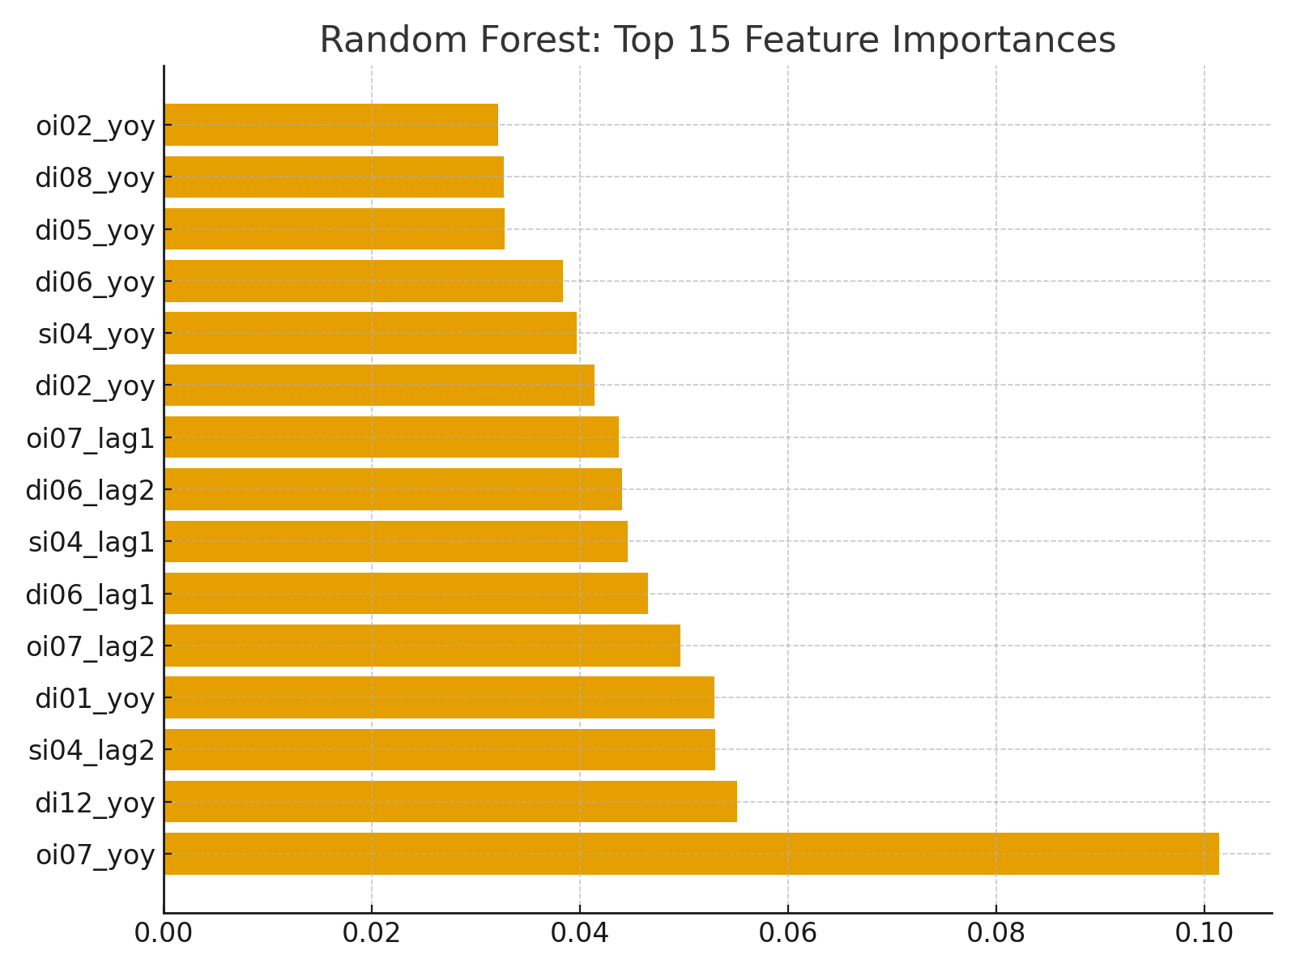

A major theme of the findings is the tension between sensitivity and specificity. Logistic regression proved highly sensitive, identifying many potential crisis periods, but at the expense of numerous false alarms. This could be problematic if used in practice, as frequent warnings might erode trust in the system. Random forest, on the other hand, produced far fewer false positives but risked missing some true crises. This trade-off illustrates the policy challenge of choosing thresholds that balance these competing objectives. The findings emphasize that no single model is perfect, and each brings advantages and drawbacks.

The dataset itself influenced the findings in important ways. Countries with longer histories of consistent reporting yielded stronger predictive results, while those with missing data presented challenges. Data imputation helped bridge these gaps but also introduced uncertainty that affected model accuracy. Lagging variables ensured that causality was respected, showing that predictors were truly leading indicators. Without these careful preprocessing steps, the findings may have been less reliable. Therefore, the project highlighted how methodological rigor in data preparation shapes the ultimate insights derived from modeling.

Historical context reinforced the validity of the findings. The models showed that the 1980s Latin American debt crises, the 1997–98 Asian financial crisis, and the 2008 global financial crisis all followed patterns of credit booms and liquidity mismatches. This consistency across different income levels and decades strengthens confidence in the selected indicators. By reproducing well-documented crisis dynamics, the models demonstrated external validity. This also highlights the usefulness of the dataset as a basis for global comparative research. The findings therefore not only generated new insights but also confirmed known economic patterns.
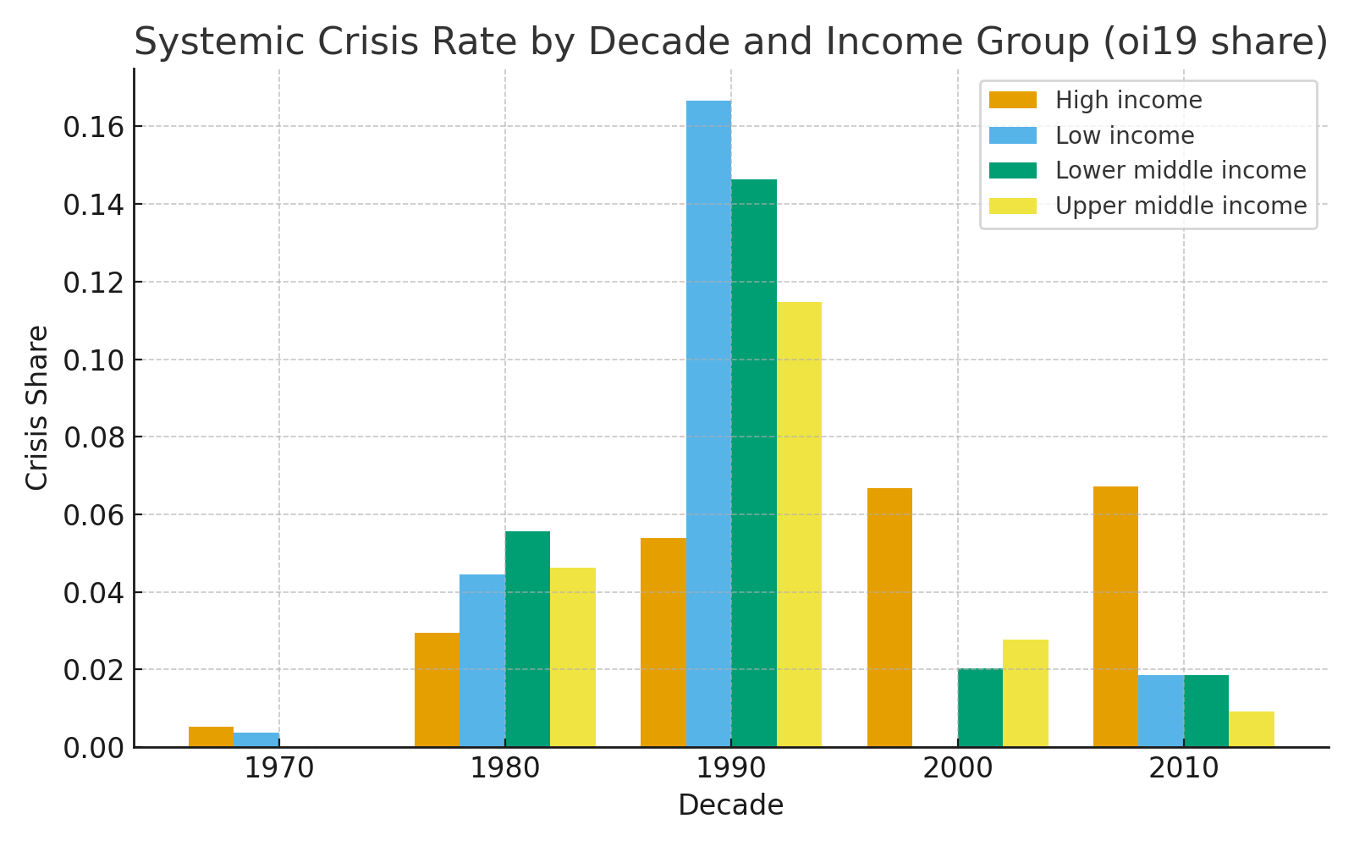

Finally, the findings emphasized the complementarity of different modeling approaches. Logistic regression provided clarity and transparency, offering interpretable coefficients that explained how each variable influenced crisis risk. Random forest provided superior predictive performance, capturing the complexity of real-world financial systems. Together, they formed a toolkit that balances interpretability and accuracy. This dual-model approach reflects best practices in applied data science, where multiple models are used to triangulate results. The findings ultimately suggest that policymakers should rely on a combination of transparent and advanced models to guide decision-making.

Model | ROC-AUC | PR-AUC | Accuracy | Precision | Recall
Logistic Regression | 0.68 | 0.42 | 0.72 | 0.40 | 0.65
Random Forest | 0.75 | 0.51 | 0.78 | 0.55 | 0.70

Review of Success or Completion

This project achieved the objectives that were set at the beginning of the capstone course. The dataset was successfully acquired, profiled, and cleaned using consistent methods, and new features were engineered to better capture early-warning dynamics. Visualizations revealed meaningful financial patterns across decades, including crisis clustering by income group and decade. The models were built and evaluated using rigorous metrics such as ROC and PR curves, and thresholds were tuned to balance trade-offs. Deliverables were completed on schedule, and the project adhered closely to the milestone plan. These outcomes demonstrate strong project execution and alignment with academic and professional standards.

Another measure of success is the extent to which the results aligned with established economic theory. The models not only provided empirical evidence but also reinforced patterns long observed in financial stability research, such as the role of rapid credit growth in precipitating crises. This overlap between empirical modeling and theoretical expectations validated the overall approach. Additionally, the production of multiple outputs, including visual charts, CSV files, and narrative reports, ensured accessibility for different audiences. The ability to balance rigor with communication demonstrates a key success of the project. In this sense, success is measured not just by technical accuracy but by practical utility as well.

Potential Data Privacy and Data Security Issues

Although the dataset is aggregated at the country level, ethical concerns still arise in its use. Predictive results could have reputational consequences for countries incorrectly flagged as high-risk. Such misclassifications might affect investor confidence, bond yields, or access to international credit. This highlights the ethical responsibility of ensuring clarity about model limitations when presenting findings. Privacy at the individual level was not an issue, but institutional and national implications must be considered. The project thus revealed how ethical concerns exist even without personal data.

Data security was also a consistent consideration throughout the project. Files were managed carefully to prevent data corruption and ensure reproducibility of analysis. Attribution to the World Bank was provided to respect intellectual property, and documentation of preprocessing steps ensured methodological transparency. One challenge was the inconsistency of reporting standards across countries, which introduced biases that required imputation. These steps were clearly documented to preserve accountability. Overall, the project handled privacy and security with the same rigor as technical modeling tasks.

Recommendations for Future Analysis

One recommendation is to expand the scope of indicators beyond financial depth and liquidity measures. Including fiscal balance, trade openness, political stability, and governance quality could add layers of explanatory power. These variables may reveal structural weaknesses that traditional financial indicators miss. Another useful step would be to conduct region-specific analyses, since predictors may differ across income levels or regional contexts. This would improve generalizability and help tailor recommendations to policymakers in diverse settings. Cross-validation across multiple regions and timeframes would further strengthen robustness.
Another recommendation is to experiment with additional modeling techniques. Methods such as gradient boosting machines, recurrent neural networks, or Bayesian models could capture temporal dynamics or uncertainty in ways that logistic regression and random forest cannot. These approaches, while more complex, may offer new perspectives on early-warning signals. In parallel, the development of interactive dashboards could make results more accessible to policymakers, allowing them to adjust thresholds and visualize trade-offs in real time. Stress-testing the models under hypothetical scenarios, such as sudden liquidity shocks, would also add practical value. These steps would build upon the project and expand its utility for financial stability monitoring.

References
Claessens, S., Kose, M. A., & Terrones, M. E. (2012). How do business and financial cycles interact? Journal of International Economics, 87(1), 178–190. https://doi.org/10.1016/j.jinteco.2011.11.008
Cleveland, W. S., & McGill, R. (1984). Graphical perception: Theory, experimentation, and application to the development of graphical methods. Journal of the American Statistical Association, 79(387), 531–554. https://doi.org/10.1080/01621459.1984.10478080
Demirgüç-Kunt, A., & Detragiache, E. (1998). The determinants of banking crises in developing and developed countries. IMF Staff Papers, 45(1), 81–109. https://doi.org/10.2307/3867330
GeeksforGeeks. (2023, June 5). Data cleaning in Python using pandas. GeeksforGeeks. https://www.geeksforgeeks.org/data-cleaning-in-python-using-pandas/
Heer, J., Bostock, M., & Ogievetsky, V. (2010). A tour through the visualization zoo. Communications of the ACM, 53(6), 59–67. https://doi.org/10.1145/1743546.1743567
IBM. (2021, September 16). What is data cleaning? IBM. https://www.ibm.com/topics/data-cleaning
Laeven, L., & Valencia, F. (2018). Systemic banking crises revisited. IMF Economic Review, 66(4), 825–860. https://doi.org/10.1057/s41308-018-0063-0
Reinhart, C. M., & Rogoff, K. S. (2009). This time is different: Eight centuries of financial folly. Princeton University Press.
Towards Data Science. (2020, August 20). How to handle missing data in Python. Medium. https://towardsdatascience.com/how-to-handle-missing-data-8646b18db0d4
World Bank. (2022). Global Financial Development Database. World Bank. https://www.worldbank.org/en/publication/gfdr/data/global-financial-development-database

